**Process design**

* 1. **What is process design?**

**Process design and product/service design are interrelated**

The design of services/products and the design of processes that make them are interrelated. Small changes in the design of products can have large effects on the way the operation has to produce them. The design of a process can constrain freedom of product/service designers to operate as they would wish.

**Process networks**

All operations are made up of networks of processes and are a part of networks of other operations. An in internal process network it has many processes that transform items and transfer them to other internal processes.

In the network there are **process chains** = threads of processes within the network

Advantages of thinking of processes as a part of a network are:

1. Understanding how and where a process fits into the internal network helps to establish appropriate objectives for the process
2. Can check to make sure that everyone in a process has a clear line of sight forward through to end customers so the people working in each process have a better chance of seeing how they contribute to satisfying the operation’s customers
3. A clear line of sight backwards through the operation’s suppliers makes the role and importance of suppliers easier to understand

* 1. **What should be the objectives of process design?**

**The point of process design** = make sure that the performance of the process is appropriate for whatever it is trying to achieve

If an operation **competes on its ability to respond quickly to customer requests**, many of its processes will need to be designed to give fast throughput times

If an operation **competes on low price**, cost-related objectives are likely to dominate its process design

**Micro process objectives**

**Micro level** and detailed set of objectives = concerned with flow through the process

When anything that is being processed enters a process, it will progress through a series of activities where it is transformed in some way. Between these activities it may dwell for some time in inventories, waiting to be transformed by the next activity → the time a unit spends in the process (**throughput time**) will be longer than the sum of all the transforming activities that it passes through

The resources that perform the process’s activities may not be used all the time because not all items will require the same activities and the capacity of each resource may not match the demand placed upon it → neither the items moving through the process nor the resources performing the activities may be fully utilized

→ the way that items leave the process is unlikely to be exactly the same as the way they arrive at the process

Some micro performance flow objectives used to describe process flow performance are:

* **Throughput rate (flow rate)** = the rate at which items emerge from the process (number of items passing through the process per unit of time
* **Cycle time** = reciprocal (inverse) of throughput rate, the time between items emerging from the process. Same as **takt time** but the latter is applied to paced processes like löpande bandet = the tempo of working required to meet demand
* **Throughput time** = average elapsed time taken for inputs to move through the process and become outputs
* **Work in progress** or **process inventory** = number of items in the process as an average over a period of time
* **Utilization of process resources** = proportion of available time that the resources within the process are performing useful work

**Standardisation of processes**

**Standardized process** = doing things the same way, adopting a common sequence of activities, methods and use of equipment

Issue in large organizations since different ways of carrying out similar tasks emerge over time in various parts of the organization. Allowing many different ways of doing the same thing would increase autonomy and freedom for individuals, but it cannot be done since it causes **confusion**, **misunderstandings** and **inefficiency**

**Environmentally sensitive process design**

Environmental protection is becoming more important and green sustainability issues need to be taken into account in process design with these fundamental issues:

* **Sources of inputs** to a product or service (what effects on environment? Child labour?)
* **Quantities and sources of energy** consumed in the process (what material uses more energy? Do we store energy waste?)
* **Amount and type of waste material** created in manufacturing processes (can it recycle or must it burn?)
* **The life of the product itself** (product lifetime cycle)
* **The end-of-life of the product** (will it deteriorate and release chemicals?)

To help make more rational decisions, **life cycle analysis** is used. It analyses all the production inputs, the life cycle use of the product and its final disposal in terms of total energy used and all emitted wastes. Inputs and wastes are evaluated at every stage of a products creation

* 1. **How do volume and variety affect process design?**

The dimensions of volume and variety go together in a reversed way:

**Low-volume processes** = produces a high variety of products and services

**High-volume processes** = produces a narrow variety of products and services

Within a single operation there could be processes with very different positions on the volume-variety spectrum

**Process types**

The position of a process on the volume-variety continuum shapes its overall design and the general approach (**process type**) to managing its activities

**Project processes**

**Project processes** = deal with discrete, highly customized products, often with a long timescale between the completion of each item where each job has a well-defined start and finish. They have **low volume and high variety**.

Activities involved in the process can be illdefined and uncertain. Transforming resources may have to be organized especially for each item

Process may be **complex** because the activities involves significant discretion to act according to professional judgement

Examples are software design and movie production

**Jobbing processes**

**Jobbing processes** = **high variety and low volumes**. Each product has to share the operation’s resources with many others.

Resources will process a series of items but they may differ in exact needs. Many jobs are usually one-offs that are never repeated

Can be complex but usually produces smaller products and involves fewer unpredictable circumstances

Examples are tailors and furniture restorers

**Batch processes**

**Batch processes** = produces more than one item at a time, each part of the process has periods when it is repeating itself (at least when the batch is being processed). **Wide range of volume and variety levels**

Examples are machine tool manufacturing and special gourmet frozen foods

**Mass processes**

**Mass processes** = produces items in **high volume and narrow variety**. Repetitive and predictable activities

Examples are frozen food production and television factories

**Continuous processes**

**Continuous processes** = higher volume and lower variety than mass processes. Operate for longer periods of times. Continuous in that the products are inseparable, being produced in a predictable flow.

Inflexible, capital-intensive technologies with highly predictable flow (smooth flow from one part of the process to another)

Examples are water processing and steel making

**Professional services**

**Professional services** = high-contact processes where customers spend a considerable time in the service process. Can provide high levels of customization. People-based rather than equipment-based

Examples are management consultants and architects

**Service shops**

**Service shops** = service is provided via mixes of front- and back-office activities. Levels of volume and variety between professional and mass services

Examples are hotels and banks

**Mass services**

**Mass services** = many customer transactions, limited contact time and little customization. Defined division of labour that follow set procedures. High volume is achieved by using a designed enquiry process

Examples are supermarkets and police service

**The product-process matrix**

**Product-process matrix** = idea that many of the more important elements of process design are strongly related to the volume-variety position of the process. For any process, the tasks that it undertakes, the flow of items through the process, the layout of its resources, the technology it uses and the design of jobs are all strongly influenced by the **volume-variety position**.

**Neutral diagonal/line of fit =** Most processes should lie close to the diagonal of the matrix that represents the fit between the process and its volume-variety position

**Moving off the natural diagonal**

A process lying on the natural diagonal of the product-process matrix will normally have lower operating costs than one with the same volume-variety position that lies off the diagonal.

Processes on the right of the diagonal would be associated with lower volumes and higher variety → more flexible than warranted by their actual volume-variety position. Not taking advantage of ability to standardize their activities so costs are likely higher than if they were closer to the diagonal

Processes on the left of the diagonal have adopted a position that would normally be used for higher-volume and lower-variety processes. These are over-standardised and too inflexible for their volume-variety position. Lack of flexibility → high costs because the process will not be able to change from one activity to another as readily as a more flexible process

A first step in examining the design of an existing process is to check if it is on the natural diagonal of the product-process matrix

* 1. **How are processes designed in detail?**

After the overall design of a process has been determined, its individual activities must be configured.

**Process mapping**

**Process mapping** **(blueprinting/analysis)** = involves describing processes in terms of how the activities within the process relate to each other. Identifies the different types of activity and show the flow of materials or people or information through the process.

**Process mapping symbols** = used to classify different types of activity

**Different levels of process mapping**

Processes are often mapped at a **high-level process mapping** before getting more detailed maps. The highest level of a process can be drawn as an input-transformation-output process with materials and customers as input resources and products/services as outputs.

At a lower level an **outline process map/chart** identifies the sequence of activities in a general way

At the more detailed level all activities are shown in a **detailed process map**

A further detailed level is the **micro detailed process map** that specifies every single motion involved in each activity.

**Mapping visibility in process design**

When customers see part of the process it is useful to map them in a way that makes the degree of visibility of each part of the process obvious

**Line of visibility** = the boundary between the activities that the customer could see and not see.

The highest level of visibility above the **line of interaction** are the activities that involve direct interaction between staff and customers

Other activities take place at the customer’s site or in the presence of the customer but involve less or no direct interaction

Further activities have a degree of visibility because they take place away from the customer but are visible to potential customers.

**Visibility, customer experience and emotional mapping**

When customers experience a process it results in the customer feeling emotions, not all of which are rational.

Any high customer contact product/service always creates an experience for the customer, and the customer experience will affect customer satisfaction which in turn has the potential to produce customer loyalty, influence expectations and create emotional bonds with customers.

**Different levels of process mapping**

Designing processes with a significant experience content requires the systematic consideration of how customers may react to the experiences that the process exposes them to – includes the sights, sounds, smells, atmosphere and the general feeling of the service

**Touchpoints** = everything the consumer uses to verify their service’s effectiveness. The points of contact between a process and customers

The accumulation of all the experiences from every touchpoint interaction shapes customers’ judgement of the process.

**Clues** = the features of a process at the touchpoints, messages that customers receive or experience as they progress through the process. Emotions that result from the clues contain the messages that the customer will receive and influence how a customer will judge the process.

**Throughput time, cycle time and work-in-progress**

The first stage of the analytical perspective is to understand the nature of and the relationship between throughput time, cycle time and work-in-progress.

**Throughput time** = elapsed time between an item entering the process and leaving

**Cycle time** = average time between items being processed

**Work-in-progress** = number of items within the process at any point in time

The **work content for each item** is important for analysis and is the total amount of work required to produce a unit of output

**Little’s law**

**Little’s law** = { throughput time = Work-in-progress x Cycle time}. The average number of things in the system is the product of the average rate at which things leave the system and the average time each one spends in the system. Also seen as the average number of objects in a queue is the product of the entry rate and the average holding time

**Throughput efficiency**

Idea that the throughput time of a process is different from the work content of whatever it is processing has important implications. For significant amounts of time no useful work is being done to the materials, information or customers that are progressing through the process.

**Throughput efficiency** = 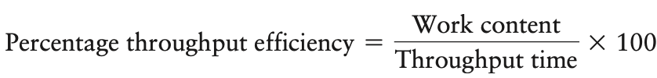

**Value-added throughput efficiency**

Work content is dependent upon the methods and technology used to perform the task. Individual elements of a task may not be considered “value-added”

**Value-added throughput efficiency** = restricts the concept of work content to only those tasks that are literally adding value to whatever is being processed. Eliminates activities such as movement, delays and inspections

**Workflow**

When a transformed resource in a process is information and when information technology is used to move, store and manage the information, process design is sometimes called **workflow** or **workflow management**.

**Workflow management** = the automation of procedures where documents, information or tasks are passed between participants according to a defined set of rules to achieve, or contribute to, an overall business goal.

Workflow is concerned with:

* Analysis, modelling, definition and subsequent operational implementation of **business processes**
* The technology that supports the processes
* The procedural decision rules that move information/documents through processes
* Defining the process in terms of the sequence of work activities, the human skills needed to perform each activity and the appropriate IT resources.

**Process bottlenecks**

**Bottleneck** = the activity/stage where congestion occurs because the workload placed is greater than the capacity to cope with it – the most overloaded part of a process

Bottlenecks reduce the efficiency of a process because the other stages will be underloaded.

**Balancing** = the activity of trying to allocate work equally between stages

**Balancing work time allocation**

Allocating work to process stages must respect the precedence of the individual tasks that make up the total work content of the job that the process is performing

**Precedence diagram** = representation of the ordering of the elements where individual tasks are represented by circles connected by arrows which signify the ordering of the tasks.

**Arranging the stages**

In any particular situation there are technical constraints which limit either how **long-thin** (sequential arrangement) or how **short and fat** (parallel arrangements) the process can be. There is usually a range of possible options within which a choice needs to be made

Advantages of **long-thin** are:

* **Controlled flow of items** – easy to manage
* **Simple handling** – especially true if items being processed are heavy, large or difficult to move
* **Lower capital requirements** – if a specialist piece of equipment is needed for one task in the job, only one piece of equipment would need to be purchased whilst on **short-fat** arrangements every stage would need one
* **More efficient operation** – if each stage is performing only a small part of the total job, the person at the stage will have a higher proportion of direct productive work as opposed to the non-productive parts of the job, such as picking up tools and materials

Advantages of **short-fat** are:

* **Higher mix flexibility** – if the process needs to work on several types of item, each stage or whole process could specialize in different types
* **Higher volume flexibility** – as volume varies, stages can simply be closed down or started up as required, **long-thin** arrangements would need rebalancing each time the cycle time changed
* **Higher robustness** – if one stage breaks down or ceases operation in one way, the other parallel stages are unaffected, a **long-thin** arrangement would cease operating completely
* **Less monotonous work** – tasks are repeated more seldom compared to in a long-thin arrangement

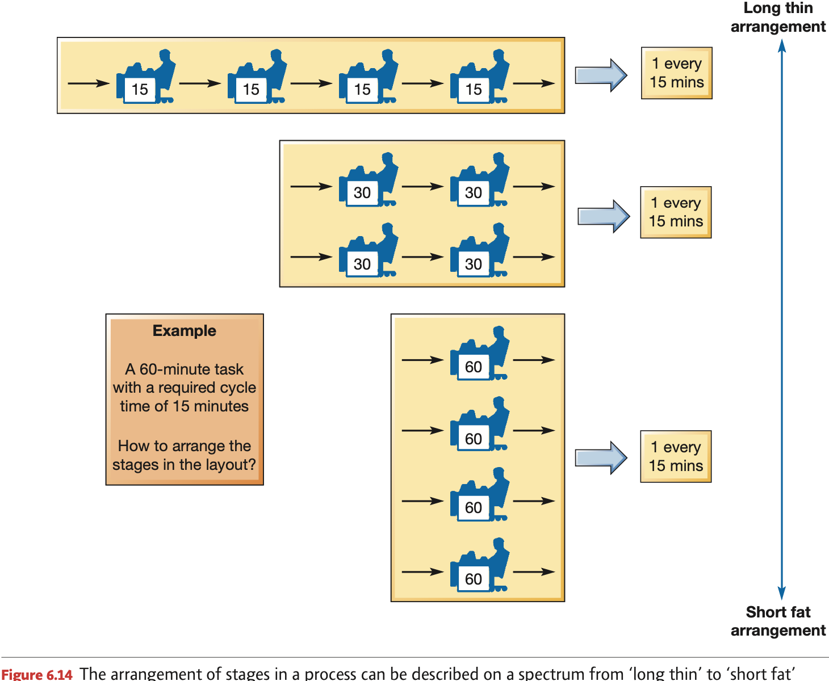

**Automating processes**

**Robotic process automation**

**Swivel chair** processes = There are many processes outside the operations function that could be automated. These are often lower volume than routine core operations processes but follow a logical set of rules. People take inputs of information from one set of systems, process the information using rules and then record the processed outputs into another system

These processes are typically routine, predictable, rules-based and performed by professional employees whose time could be more profitably employed

**Robotic process automation** = tools that function on the human interface of other computer systems, deploying software routines to perform the most mundane and repetitive tasks previously done by people.

Comparing traditional IT systems with RPA:

* RPA best used away from the extremes of the volume-variety spectrum. High-volume and low-variety processes can be automated using IT systems. High-variety and low-volume tasks need the flexible thought processes and decision making of humans
* RPA is easy to develop compared with specifically designed IT systems. IT requires systems analysis and coding skills while RPA can use drag and drop instructions
* RPA works around existing processes rather than trying to reengineer them, does not try to disturb underlying computer systems

**The effects of process variability**

Variability occurs in processes for many reasons. These can include the late or early arrival of material, information or customers, a temporary malfunction or breakdown of process technology within a stage of the process.

The sources of variation interact with each other and result in 2 fundamental types of variability:

1. **Variability in the demand for processing** at an individual stage within the process. Usually expressed in terms of variation in the inter-arrival times of items to be processed
2. **Variation in the time taken** to perform the activities at each stage

**Arrival variability** effect on process performance. In a perfectly constant and predictable world the relationship between process waiting time and utilization is a rectangular function. When arrival and process times are variable, sometimes the process will have items waiting to be processed while at other times the process will be idle waiting for items to arrive → the process will have both a non-zero average queue and be underutilized in the same period

As the process moves closer to 100 per cent utilization, the average waiting time will become longer. The only way to guarantee very low waiting times for the items is to suffer low process utilization

The greater the variability in the process, the more the waiting time-utilisation relationship deviates from the simple rectangular function of the no variability conditions

Process designers have 3 options to improve waiting time or utilization performance of their processes:

1. **Accept long average waiting times and achieve high utilization (point X)**
2. **Accept low utilization and achieve short average waiting times (point Y)**
3. **Reduce the variability in arrival times, activity times or both, and achieve higher utilization and short waiting times (point Z)**

Queuing or waiting line analysis can be used to analyze processes with both inter-arrival and activity time variability. The only way to have fast throughput time and high utilization of resources simultaneously is to reduce variability in its processes which may require strategic decisions such as limiting the degree of customization of products or services or imposing stricter limits on how products or services can be delivered to customers.